Module 10

Assignment 10.2
Course: CSD420-340A Advanced Java for Programmers
Prepared By: Mirach Erkol
Date of Report: 5/17/2026

https://github.com/Mikey5007/csd-420.git

10.2 Assignment: Creating Tables in MYSQL

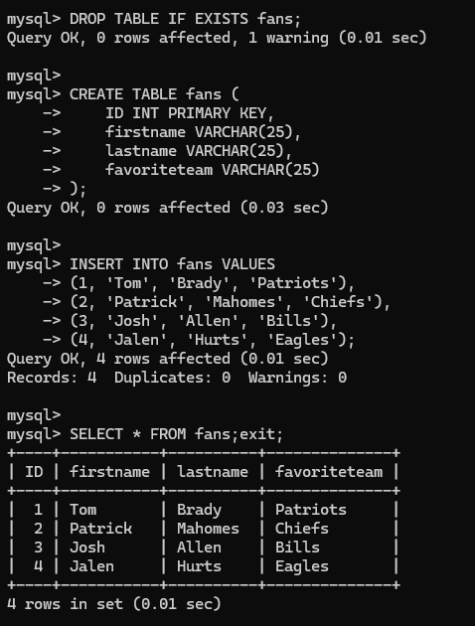

10.2 Assignment: Successfully Running TestDB File
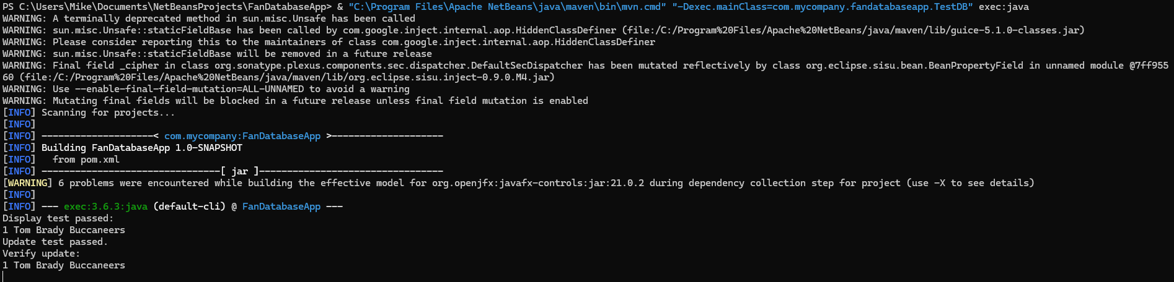

10.2 Assignment: GUI running
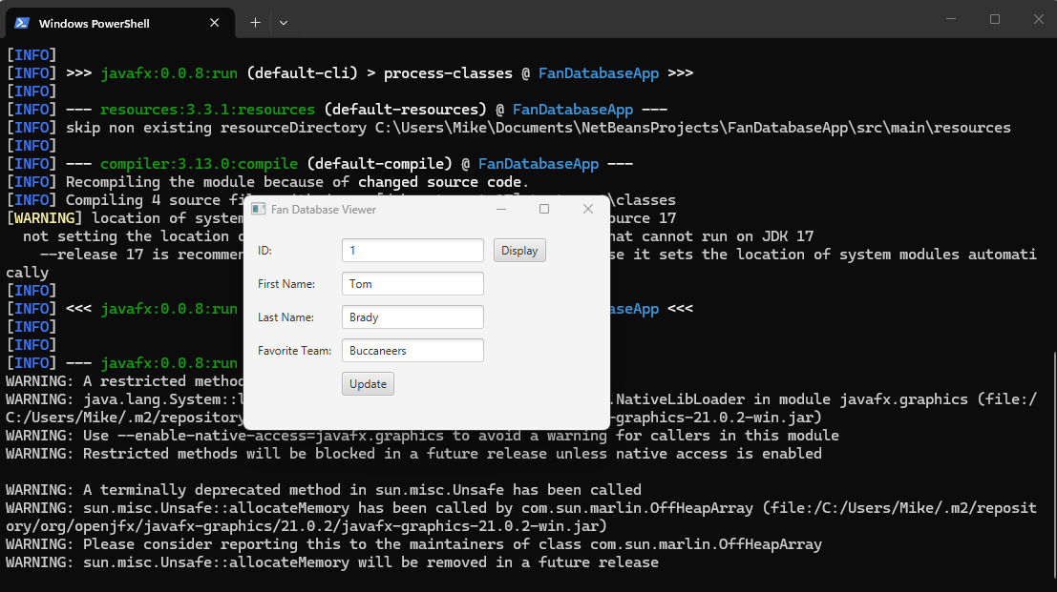

10.2 Assignment: Successfully updating record with GUI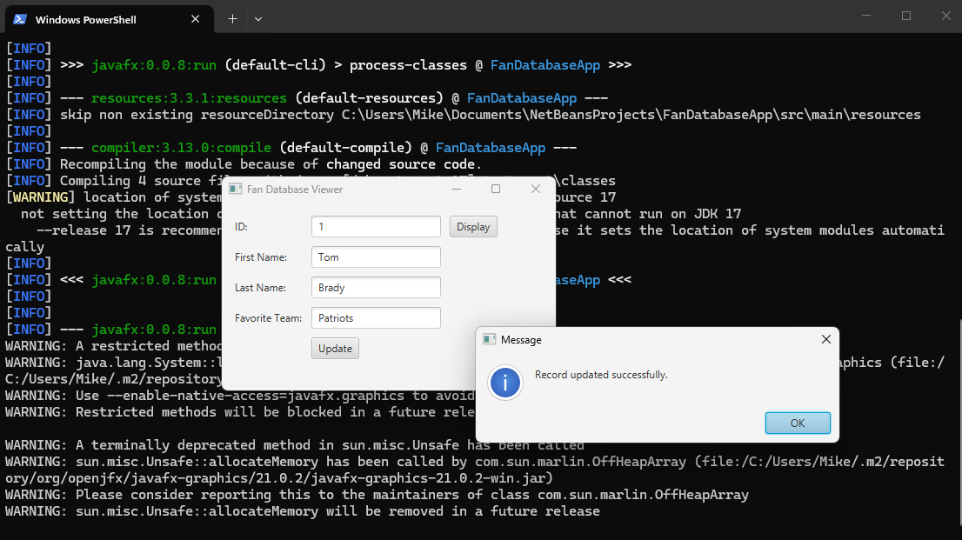

10.2 Assignment: GUI Displaying Error When No Record Found
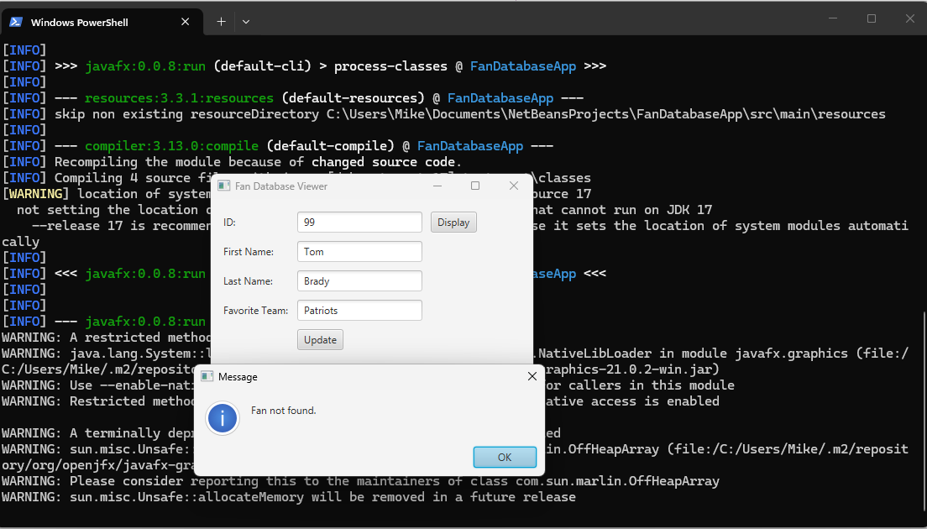

10.2 Assignment: Final MYSQL Table After Updates With GUI
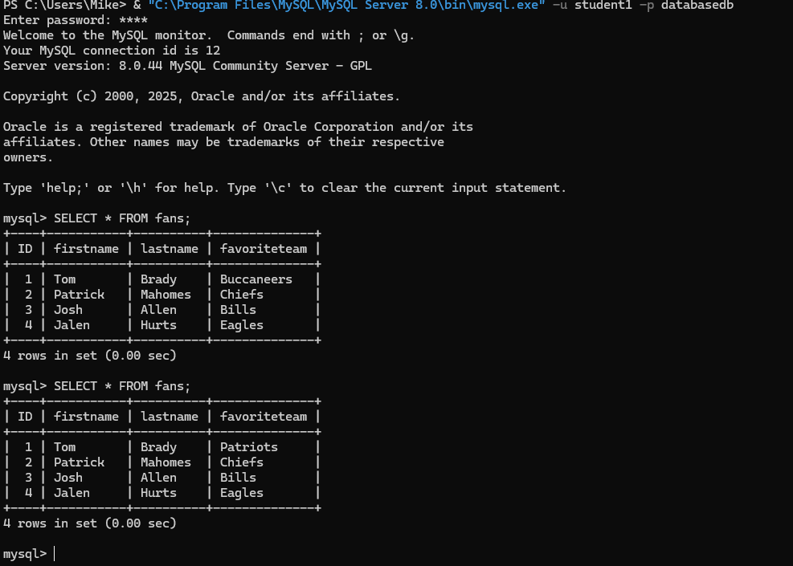

References:

https://github.com/Mikey5007/csd-420.git

